✦ V3 ✦

Build a Research-Powered Blog Writer Agent

Web Research Edition — Vibe Coding Guide for Non-Tech Students

8 Prompts | No Code | Tavily Search | Real Sources

Tool: Antigravity (Google AI Coding IDE) | AI PM Cohort · Ashu Mishra

What's Improved in V3 — And Why It Matters

V3 adds one enormous new capability: the agent can now go to the web and read real sources before writing. This makes it suitable for current-events topics, news roundups, rankings, and anything where training data is stale. Read this page before building anything.

Area | V2 — What it had | V3 — What's new | Why this makes it better
Biggest addition | No web search — agent only uses its training data | Tavily real-time web search — agent fetches live articles, rankings, and news before writing | Topics like 'State of AI in 2026' can't be answered from training data. Tavily gives the agent current sources to cite.
New Router node | None — went straight to planning | Router runs FIRST. Decides: does this topic need research? Returns mode: closed_book, hybrid, or open_book | Not every topic needs web search. Asking for real-time data on 'what is recursion' wastes money. The router is smart about this.
New Research node | None | Calls Tavily with 3–10 targeted queries, collects raw results, uses LLM to deduplicate and clean into structured EvidenceItem objects | Raw search results are noisy. This step transforms messy JSON into clean, usable evidence with title, URL, snippet.
New data models | Task, Plan, State (3 models) | Added EvidenceItem, RouterDecision, EvidencePack — 6 models total | Each new model represents a real concept: a web search decision, a piece of evidence, a pack of cleaned results.
Task model flags | section_type (Literal enum) | Three boolean flags: requires_research, requires_citations, requires_code. Plus tags list | Per-section control. One section may need citations, another needs a code snippet. The writer knows exactly what each section demands.
Plan model | blog_title, audience, tone, tasks | Adds blog_kind (explainer/tutorial/news_roundup/comparison/system_design) + constraints list | blog_kind prevents the agent from writing a 'how-to tutorial' when the user asked for a 'news roundup'. Scope control.
State | sections as List[str] | sections as List[tuple[int, str]] — task_id + content | Parallel workers finish in random order. Storing (id, content) tuples lets the reducer sort sections back into the correct order.
Orchestrator prompt | Three-mode awareness (closed/hybrid/open). Evidence passed in. Open_book → news_roundup forced | V2 had no modes — one prompt for all topics | A concept blog (closed_book) needs no citations. A news roundup (open_book) must cite everything. One prompt can't serve both.
Worker grounding policy | None — worker could hallucinate any claim | In open_book mode: EVERY event/company/model claim must have a citation URL from Evidence. No source = 'Not found in provided sources.' | Prevents hallucination. The worker can't invent facts — it can only use URLs from the evidence list.
Worker scope guard | None | news_roundup mode blocks the worker from turning sections into tutorials/how-to guides | Without this, workers drift. A 'news roundup about AI' becomes a 'how to use AI' tutorial because that's what the LLM defaults to.
Reducer section order | Joined in whatever order workers finished | Sorts sections by task.id before joining — correct order guaranteed | Workers run in parallel and finish at different times. V3 ensures the blog reads in the right order regardless of which worker finishes first.
Runner function | Direct app.invoke() call in the notebook | Clean run(topic) function with all state fields pre-initialized | Cleaner API. All state initialization in one place — no need to remember which fields to pass each time.

The Core Insight of V3
V2 was a great writer but a blind one — it only knew what was in its training data. V3 gives the agent eyes. Before it plans or writes, it goes to the web, reads current sources, and builds an evidence pack. Then the writer is constrained to only cite URLs from that pack — no hallucination allowed. This is how production research-writing systems actually work.
Flowchart
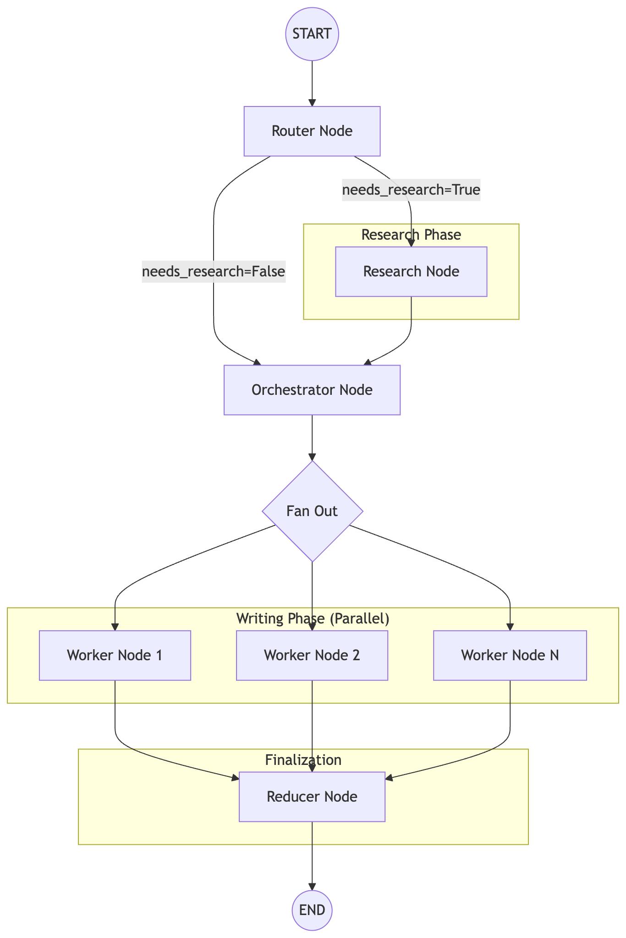

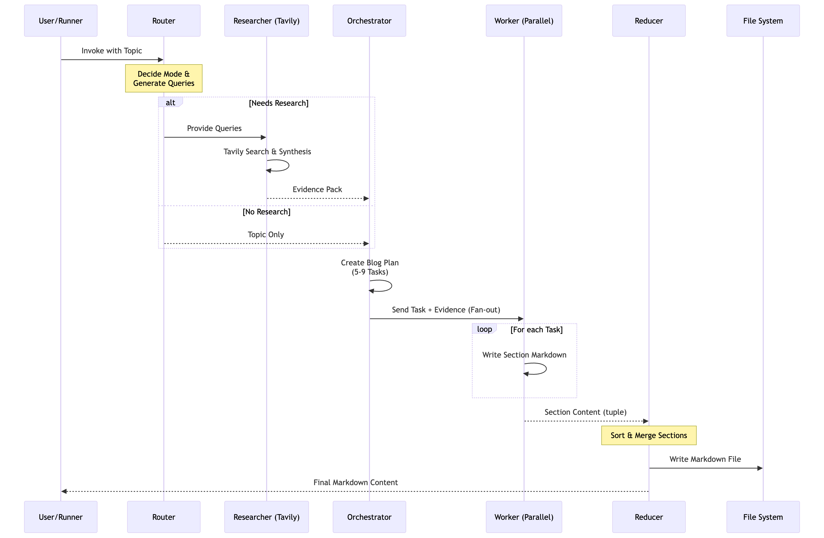

Sequence Diagram

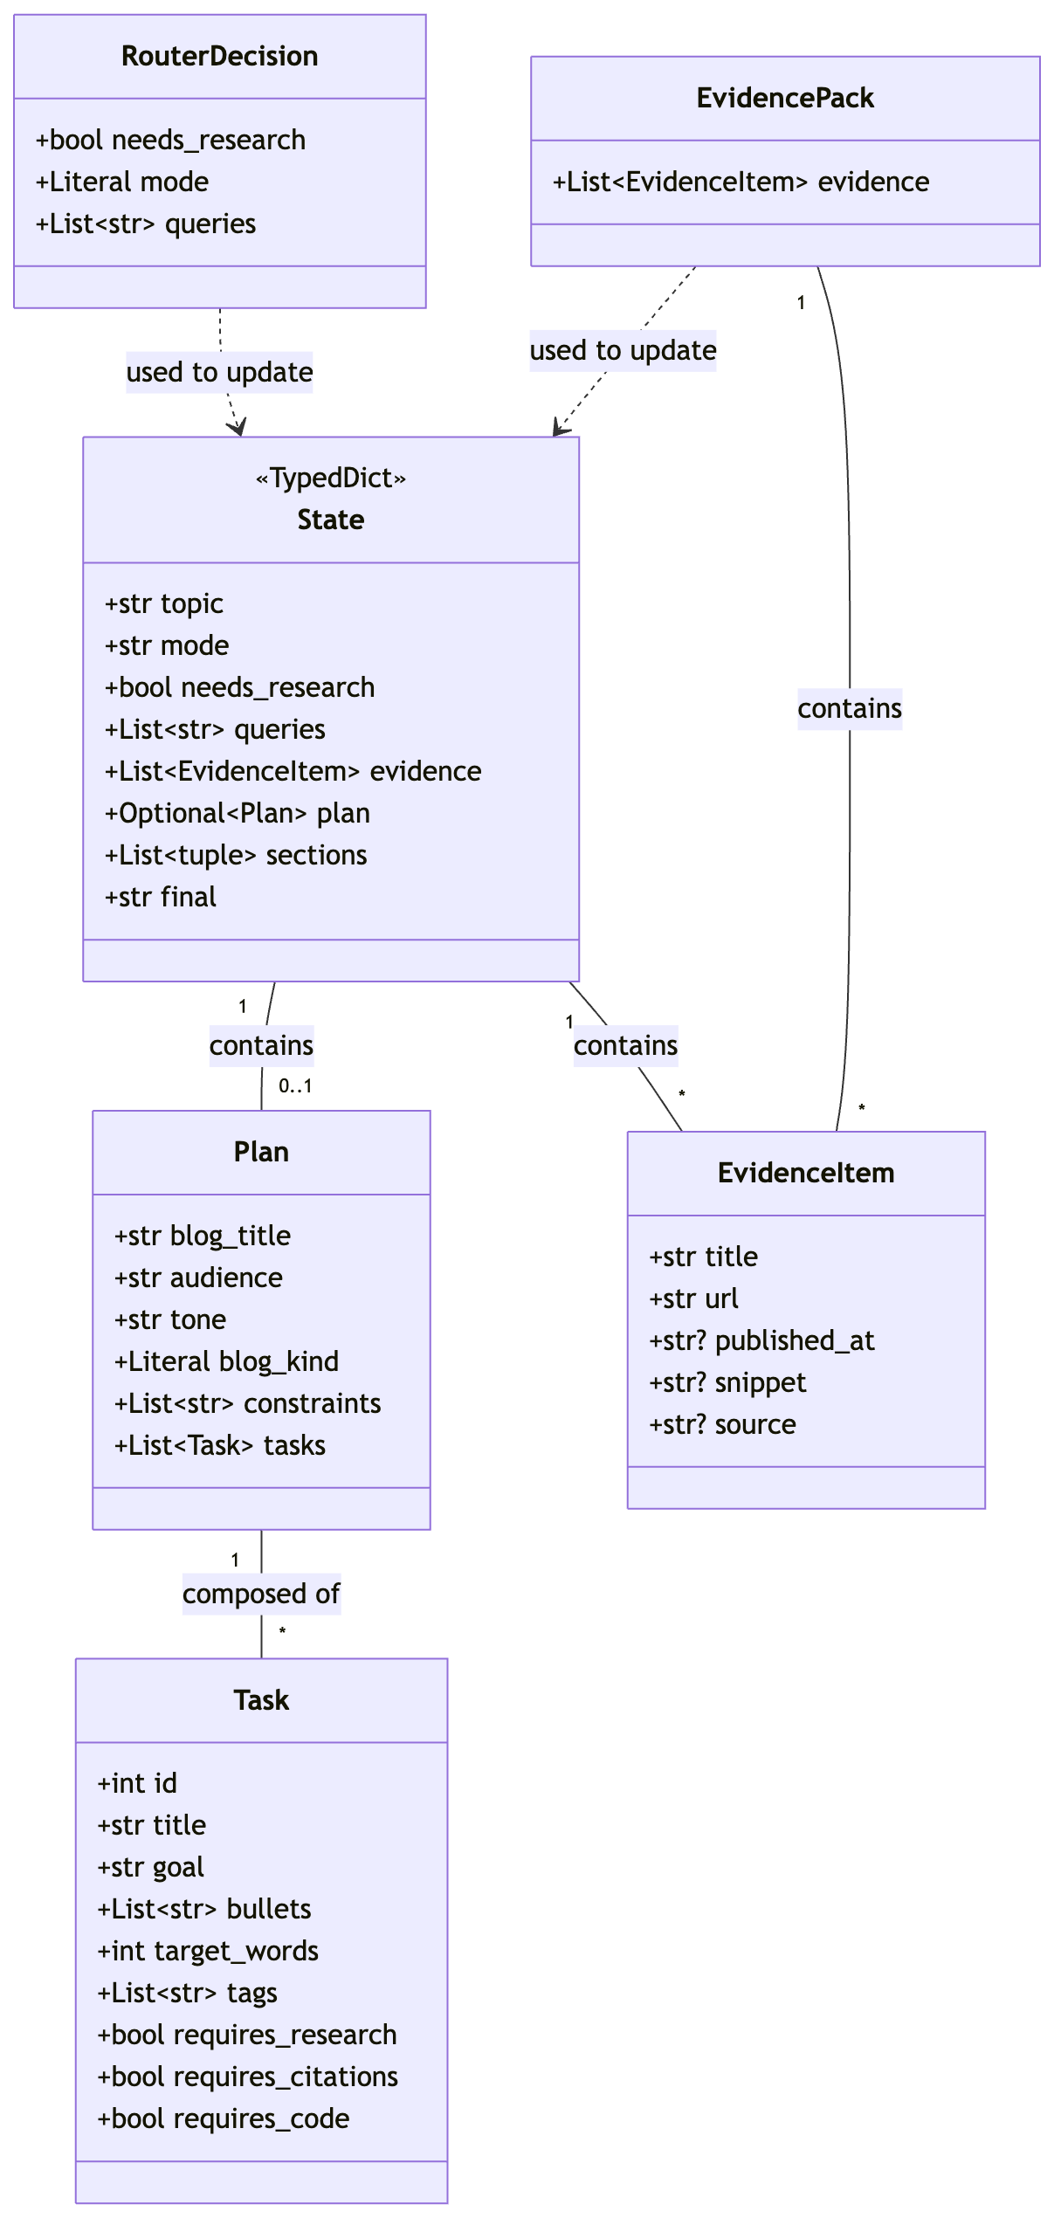

Class Diagram

How to Use This Guide

This is a vibe coding guide. You describe what you want in plain English. Antigravity writes the code. You are the architect. Your job is to understand what you asked for.

Step 1 | Read 'What's happening here' first. Understand the concept before you open Antigravity.

Step 2 | Open Antigravity. Start a new Python project (or continue from V2 if you built it).

Step 3 | Copy the prompt from the dark box and paste into Antigravity. Read what comes back.

Step 4 | Check the 'What you should see' list. If something is wrong, describe the problem to Antigravity in plain English — do not search Stack Overflow.

Step 5 | Before running, make sure your .env file has BOTH OPENAI_API_KEY and TAVILY_API_KEY. See the last page for how to get the Tavily key.

🛠️  STEP 01 | Project Setup & Imports  Two API keys, one new library — understand what Tavily is before you install it

What's happening here?
The imports in V3 are almost the same as V2, with one important addition: TavilySearchResults from langchain_community.tools.tavily_search. Tavily is a web search API built specifically for AI agents — it returns clean, structured results designed to be consumed by an LLM, not a human browser.
Unlike a normal Google search that returns HTML pages, Tavily returns JSON with title, URL, snippet, and sometimes a publication date. This makes it easy for the agent to process search results programmatically.
You also need two API keys now — not just one. Your .env file must have both OPENAI_API_KEY (same as before) and TAVILY_API_KEY (new). The last page of this guide tells you exactly how to get the Tavily key for free.
One small note: the typing imports also add Optional — used for fields that might be None, like published_at on an evidence item where the date isn't always available.

⚡ What's improved vs V2 in this step

- New import: TavilySearchResults from langchain_community.tools.tavily_search
- New import: Optional from typing — for nullable fields in the evidence models
- Two API keys now required: OPENAI_API_KEY and TAVILY_API_KEY

YOUR PROMPT — Copy and paste into Antigravity

I want to build V3 of my Blog Writer Agent in Python. This version can search the web using Tavily before writing.

Please create a new Python file called blog_agent_v3.py.

At the top, I need these imports:
- Everything from LangGraph for graph-based agents (StateGraph, START, END, Send)
- LangChain with OpenAI (ChatOpenAI, SystemMessage, HumanMessage)
- Pydantic for data models (BaseModel, Field)
- Python's typing tools: TypedDict, List, Optional, Literal, Annotated
- Python's pathlib module (Path) for saving files
- operator for the add reducer
- TavilySearchResults from langchain_community.tools.tavily_search — this is a web search tool built for AI agents
- dotenv for API key loading

Create a .env file with two placeholders:
- OPENAI_API_KEY=your_openai_key_here
- TAVILY_API_KEY=your_tavily_key_here

Install all required packages. After setup, explain:
1. What is Tavily and how is it different from a normal Google search?
2. Why does an AI agent benefit from a search tool built specifically for LLMs?

✅ What you should see after this step

- blog_agent_v3.py with all imports at the top — no errors
- TavilySearchResults is imported (this is new vs V1 and V2)
- Optional is in the typing imports
- .env file with two placeholders — one for OpenAI, one for Tavily
- An explanation from Antigravity about what Tavily is and why it's useful for AI agents

📐  STEP 02 | Build All Six Data Models  Three new models for research — EvidenceItem, RouterDecision, EvidencePack

What's happening here?
V2 had 3 data models. V3 has 6. The 3 new ones handle the research pipeline.
EvidenceItem represents a single search result — a title, a URL, an optional snippet of text, and an optional publication date. The date field is Optional because Tavily doesn't always include it, and the model is strict: never guess a date if it isn't explicitly provided.
RouterDecision is what the first node (the Router) returns. It contains a boolean (needs_research?), a mode string (closed_book / hybrid / open_book), and a list of search queries to run if research is needed.
EvidencePack is a container for a list of EvidenceItems — used by the LLM to return a clean, deduplicated list of evidence after processing raw Tavily results.
The Task model gains three new boolean flags: requires_research, requires_citations, requires_code. These are per-section instructions — one section might need code, another needs citations, another is purely conceptual. The Plan model adds blog_kind (explainer/tutorial/news_roundup/comparison/system_design) and a constraints list.
The State now tracks mode, needs_research, queries, and evidence. And crucially — sections changes from List[str] to List[tuple[int, str]]. This stores (task_id, content) pairs so the reducer can sort sections back into the correct order after parallel workers finish in random sequence.

⚡ What's improved vs V2 in this step

- 3 new Pydantic models: EvidenceItem, RouterDecision, EvidencePack
- Task gains: requires_research, requires_citations, requires_code flags + tags list
- Plan gains: blog_kind (Literal with 5 options) + constraints list
- State gains: mode, needs_research, queries, evidence fields
- sections type changes: List[str] → List[tuple[int, str]] for ordered parallel output

YOUR PROMPT — Copy and paste into Antigravity

Now create all 6 data models for my V3 Blog Writer Agent.

Model 1 — EvidenceItem (Pydantic):
A single search result from the web. Fields: title (string), url (string), published_at (optional string — only if explicitly provided, never guessed), snippet (optional string — short summary), source (optional string).

Model 2 — RouterDecision (Pydantic):
The output of the routing decision. Fields: needs_research (boolean), mode (Literal: exactly one of "closed_book", "hybrid", or "open_book"), queries (list of strings — the search queries to run, empty if no research needed).

Model 3 — EvidencePack (Pydantic):
A container for a cleaned list of evidence items. Fields: evidence (list of EvidenceItems, default empty list).

Model 4 — Task (Pydantic):
One section brief for the blog. Fields: id (integer), title (string), goal (string — one sentence), bullets (list of strings, minimum 3, maximum 6), target_words (integer, 120–550), tags (list of strings, default empty), requires_research (boolean, default False), requires_citations (boolean, default False), requires_code (boolean, default False).

Model 5 — Plan (Pydantic):
The full blog plan. Fields: blog_title (string), audience (string), tone (string), blog_kind (Literal: one of "explainer", "tutorial", "news_roundup", "comparison", "system_design", default "explainer"), constraints (list of strings, default empty), tasks (list of Task objects).

Model 6 — State (TypedDict):
The shared agent memory. Fields: topic (string), mode (string), needs_research (boolean), queries (list of strings), evidence (list of EvidenceItems), plan (optional Plan), sections (list of tuples of int and string — each tuple holds a task id and section content, uses operator.add as the reducer), final (string).

Also initialize the LLM: use ChatOpenAI with model gpt-4o-mini.

After writing the models, explain: why does sections store tuples of (id, content) instead of just strings? What problem does this solve when parallel workers finish out of order?

✅ What you should see after this step

- 6 Pydantic / TypedDict models: EvidenceItem, RouterDecision, EvidencePack, Task, Plan, State
- Task has requires_research, requires_citations, requires_code boolean flags
- Plan has blog_kind as a Literal with 5 allowed values
- State.sections is List[tuple[int, str]] with operator.add
- llm = ChatOpenAI(model='gpt-4o-mini')
- An explanation of why (id, content) tuples fix the ordering problem

🗺️  STEP 03 | Build the Router Node  The new first node — decides whether to search the web or go straight to planning

What's happening here?
V2 went straight from Start to the Orchestrator. V3 adds a Router as the very first node.
The Router's job is simple but important: read the topic and decide whether web research is needed. It classifies every topic into one of three modes:
closed_book: Evergreen topics where correctness doesn't depend on recent facts — things like 'what is recursion' or 'how does attention work'. No search needed. Training data is enough.
hybrid: Mostly evergreen but benefits from up-to-date examples — like 'how to use React hooks' where the concept is stable but the best tools/libraries change over time.
open_book: Mostly volatile — topics like 'state of AI in 2026', 'this week in LLMs', 'latest GPT-4 pricing'. These MUST be researched with current sources or the blog will be full of stale or hallucinated information.
If research is needed, the Router also generates 3–10 targeted search queries. These are specific, scoped queries — not just 'AI' but 'latest multimodal LLM benchmarks 2026'. A separate route_next function reads the needs_research flag and decides the next node: research (if True) or orchestrator (if False).

⚡ What's improved vs V2 in this step

- Entirely new node — did not exist in V2
- Prevents unnecessary Tavily API calls for evergreen topics (saves cost)
- Three-mode classification: closed_book / hybrid / open_book
- Generates targeted search queries when research is needed
- Adds route_next routing function for the conditional edge

YOUR PROMPT — Copy and paste into Antigravity

Now create the Router node for my V3 agent. This is the very first node that runs — it decides whether to search the web or go straight to planning.

The router_node function should:
- Receive the State as input
- Use llm.with_structured_output(RouterDecision) to get a structured decision
- Use a system prompt that explains the three modes:
* closed_book (needs_research=False): evergreen topics where correctness does not depend on recent facts — concepts, fundamentals
* hybrid (needs_research=True): mostly evergreen but needs up-to-date examples, tools, or models to be useful
* open_book (needs_research=True): mostly volatile — weekly roundups, "this week", "latest", rankings, pricing, policy/regulation
- If needs_research is True, the system prompt should instruct the AI to output 3–10 high-signal, specific search queries (not generic like "AI" — queries should be scoped and specific)
- If the user mentioned "last week", "this week", or "latest" in their topic, that time constraint must appear in the queries
- The human message passes the topic from state
- Return needs_research, mode, and queries back to state

Also create a route_next function that:
- Takes State as input
- Returns the string "research" if state["needs_research"] is True
- Returns the string "orchestrator" if state["needs_research"] is False
This function will be used for the conditional edge in the graph.

After writing both functions, explain: what would happen to the blog quality if we skipped the router and always went to research — even for an evergreen topic like "what is recursion"?

✅ What you should see after this step

- A router_node function using llm.with_structured_output(RouterDecision)
- A system prompt explaining all three modes with clear rules
- A route_next function that returns 'research' or 'orchestrator' based on state
- The function returns needs_research, mode, and queries
- Antigravity's explanation of what happens without smart routing

🔍  STEP 04 | Build the Research Node  Tavily web search + LLM cleaning = a structured evidence pack ready for the writer

What's happening here?
This is the node that makes V3 genuinely different from everything before it. The research_node runs Tavily searches and converts raw web results into clean, structured evidence.
Step 1 — Raw search: A private helper function _tavily_search runs each query through TavilySearchResults. For each query, it fetches up to 6 results. It normalises the fields (title, url, snippet, published_at, source) because Tavily's raw JSON has slightly inconsistent field names depending on the source.
Step 2 — LLM cleaning: The raw results are passed to the LLM with a system prompt acting as a 'research synthesizer'. The LLM's job: deduplicate by URL, prefer authoritative sources (company blogs, docs, reputable outlets over forums), keep snippets short, and if a publication date is explicitly present keep it — if missing, set it to null. Never guess.
Step 3 — Final dedup: After the LLM returns an EvidencePack, the code does a final Python-level deduplication by URL to be absolutely sure there are no duplicates.
The result is a clean list of EvidenceItem objects — titles, URLs, snippets — that the orchestrator and workers can rely on as their source of truth for citations.

⚡ What's improved vs V2 in this step

- Entirely new node — did not exist in V2
- _tavily_search helper normalises inconsistent field names from Tavily's raw JSON
- LLM synthesizer deduplicates, prefers authoritative sources, and enforces null dates
- Final Python-level URL dedup as a safety net
- Output is a clean List[EvidenceItem] — structured, not raw text

YOUR PROMPT — Copy and paste into Antigravity

Now create the Research node for my V3 agent. This is the node that searches the web using Tavily and returns clean structured evidence.

First, create a private helper function called _tavily_search that:
- Takes a query string and a max_results integer (default 5)
- Creates a TavilySearchResults tool with max_results
- Calls tool.invoke with the query
- Normalises each result into a dictionary with these keys: title, url, snippet (from content or snippet field), published_at (from published_date or published_at field — may be None), source
- Returns a list of these normalised dictionaries

Then, create the main research_node function that:
- Gets the list of queries from state
- For each query, calls _tavily_search with max_results=6 and collects all raw results into one list
- If no results come back, returns {"evidence": []}
- Uses llm.with_structured_output(EvidencePack) with a system prompt that tells the AI to act as a research synthesizer
- The system prompt must instruct the LLM to: only include items with a non-empty URL, prefer authoritative sources (company blogs, documentation, reputable outlets), keep snippets short, if a published date is explicitly present keep it as YYYY-MM-DD, if missing set it to null and never guess, and deduplicate by URL
- Passes the raw results as the human message
- After the LLM returns an EvidencePack, does a final Python-level deduplication by URL using a dictionary
- Returns {"evidence": list of deduplicated EvidenceItems}

After writing this, explain: why does the research node have TWO deduplication steps — one by the LLM and one in Python? Why not just one?

✅ What you should see after this step

- A _tavily_search helper function that returns normalised result dictionaries
- A research_node function that loops through queries and collects raw results
- The LLM is called with llm.with_structured_output(EvidencePack)
- A system prompt telling the LLM to deduplicate, prefer authoritative sources, and never guess dates
- A final Python-level deduplication by URL using a dict
- Returns {'evidence': list_of_evidence_items}
- Antigravity's explanation of why two deduplication steps are better than one

🧠  STEP 05 | Build the Evidence-Aware Orchestrator  The planner now knows what mode it's in and what sources are available

What's happening here?
V2's orchestrator had one system prompt for all topics. V3's orchestrator receives two critical pieces of context: the mode (closed_book / hybrid / open_book) and the evidence list from the research node.
The system prompt now has three different sets of behaviour instructions depending on mode. In closed_book mode: keep the blog evergreen, don't reference specific tools or models that might be outdated, no citations needed. In hybrid mode: use evidence for up-to-date examples, mark sections that use fresh information with requires_research=True and requires_citations=True. In open_book mode: force blog_kind to news_roundup, every section is about summarising events and implications — NOT tutorials or how-to guides. If evidence is empty or insufficient, the plan should transparently say so.
The human message now passes the topic, the mode, and up to 16 evidence items. The orchestrator uses the evidence to inform which specific models, tools, or events to mention in the Task bullets — but only if the mode calls for it.
This is what makes the research pipeline complete: the evidence gathered in Step 4 flows directly into the plan in Step 5, and then from the plan into each worker in Step 6.

⚡ What's improved vs V2 in this step

- V2: one system prompt, no awareness of mode or evidence
- V3: three-mode system prompt — different behaviour for closed_book, hybrid, open_book
- Evidence list passed to the orchestrator — up to 16 items used to inform Task bullets
- open_book mode forces blog_kind = 'news_roundup' and blocks tutorial sections
- hybrid mode marks specific tasks with requires_research=True and requires_citations=True

YOUR PROMPT — Copy and paste into Antigravity

Now create the Orchestrator node for my V3 agent. This is the planner — it receives the mode and evidence, and produces a structured Plan.

The orchestrator_node function should:
- Get the evidence list from state (default empty if not present)
- Get the mode from state (default "closed_book" if not present)
- Use llm.with_structured_output(Plan) to return a structured plan
- Use a detailed system prompt with hard requirements and three-mode grounding rules:

Hard requirements for all modes:
- Create 5 to 9 sections (tasks) suitable for the topic and audience
- Each task must have: a goal (one sentence), 3–6 concrete bullets, a target word count (120–550)
- Bullets must be actionable: build/compare/measure/verify/debug — not vague like "explain X"
- The overall plan must include at least 2 of: code sketch, edge cases/failure modes, performance/cost considerations, security considerations, or debugging/observability tips

Three-mode grounding rules:
- Mode closed_book: keep the content evergreen, do not depend on the evidence
- Mode hybrid: use evidence for up-to-date examples in bullets, mark any section using fresh info with requires_research=True and requires_citations=True
- Mode open_book: set blog_kind to "news_roundup", every section should summarise events and implications, do NOT include tutorial sections unless the user explicitly asked for them, if evidence is empty or insufficient the plan should note this transparently

The human message should pass: the topic, the mode, and the evidence (up to 16 items, serialised with model_dump())
Return {"plan": plan}

After writing this, explain: why does the orchestrator need to know the mode at planning time — not just at writing time?

✅ What you should see after this step

- An orchestrator_node function using llm.with_structured_output(Plan)
- A long system prompt with hard requirements AND three-mode grounding rules
- The human message includes topic, mode, and evidence
- Evidence is passed as model_dump() serialised objects, up to 16 items
- Returns {'plan': plan}
- Antigravity's explanation of why mode awareness at planning time matters

⚡  STEP 06 | Build the Worker Node + Fan-Out  Writers now have grounding rules — every citation must come from real evidence URLs

What's happening here?
V2's workers wrote freely — they could mention any model, tool, or event they knew about from training data. In open_book mode, this would mean hallucinating current events.
V3's workers have a grounding policy in the system prompt. If mode is open_book: the worker MUST NOT introduce any specific event, company, model, or funding claim unless it is supported by an evidence URL. For every such claim, it must attach the URL as a Markdown link. If a claim is not in the evidence, it must write: 'Not found in provided sources.' This is how production research-writing systems prevent hallucination.
There is also a scope guard: if blog_kind is news_roundup, the worker must not turn the section into a tutorial or how-to guide. Workers naturally drift toward explaining things step-by-step — the scope guard prevents this.
The worker also respects the three boolean flags from the Task: requires_code means at least one code snippet must be included; requires_citations means all outside-world claims need a citation URL; requires_research is informational.
The fan-out function is similar to V2 but now passes additional context through each Send(): the mode, the full plan (serialised with model_dump()), and the full evidence list (serialised). Each worker gets everything it needs.

⚡ What's improved vs V2 in this step

- Grounding policy: open_book workers must only cite URLs from the evidence list
- Hallucination guard: unsupported claims must say 'Not found in provided sources'
- Scope guard: news_roundup mode blocks workers from writing tutorials
- requires_code flag enforced — workers include code if the task demands it
- requires_citations flag enforced — citations required for outside-world claims
- Fan-out passes mode, plan (model_dump), and evidence to every worker

YOUR PROMPT — Copy and paste into Antigravity

Now create the Worker node and the fan-out function for my V3 agent.

Worker node (call it worker_node):
- Receives a payload dict containing: task (dict), plan (dict), evidence (list of dicts), topic (string), mode (string)
- Reconstruct the objects: Task(**payload["task"]), Plan(**payload["plan"]), and a list of EvidenceItem objects from the evidence dicts
- Format the task's bullets as a numbered bullet list string
- Format the evidence as a string with one item per line: title | url | published_at (or "date:unknown")
- Use a detailed system prompt that tells the AI it is a senior technical writer writing ONE section in Markdown
- The system prompt must include:
* Hard constraints: cover all Bullets in order, stay within ±15% of target word count, output only section content starting with ## heading
* Scope guard: if blog_kind is "news_roundup", do NOT turn the section into a tutorial or how-to guide — focus on summarising events and implications
* Grounding policy: if mode is "open_book", do NOT introduce any specific event, company, model, funding, or policy claim unless it is supported by an evidence URL — for each such claim, attach the URL as a Markdown link using ([Source](URL)) format — if the claim is not in evidence, write "Not found in provided sources."
* Citation rule: if requires_citations is True, cite evidence URLs for outside-world claims the same way
* Code rule: if requires_code is True, include at least one minimal correct code snippet
* Style: short paragraphs, bullets where helpful, code fences for code, no fluff or marketing language
- The human message passes: blog title, audience, tone, blog_kind, constraints, topic, mode, section title, goal, target_words, tags, requires_research, requires_citations, requires_code, bullets, and the evidence text
- Returns {"sections": [(task.id, section_md)]} — a tuple of id and content for correct ordering later

Fan-out function (call it fanout):
- Takes State as input
- Uses LangGraph's Send() to launch one worker_node per task in state["plan"].tasks simultaneously
- Each Send() passes: task as model_dump(), topic, mode, plan as model_dump(), evidence as a list of model_dump() objects

After writing both, explain: what would happen if we removed the grounding policy and let workers write freely in open_book mode?

✅ What you should see after this step

- A worker_node function that reconstructs Task, Plan, and EvidenceItem objects from the payload
- A system prompt with grounding policy, scope guard, code rule, and citation rule
- The human message includes all context: blog_kind, mode, tags, all three boolean flags, and evidence text
- Returns {'sections': [(task.id, section_md)]} — a tuple, not just a string
- A fanout function using Send() that passes task.model_dump(), plan.model_dump(), and evidence as dicts
- Antigravity's explanation of why removing the grounding policy causes hallucination

🗂️  STEP 07 | Build the Reducer Node  Sort sections by task ID — guaranteed correct order even when workers finish randomly

What's happening here?
V2's reducer just joined sections in whatever order they arrived. This worked most of the time in V2 because parallel workers usually finish in roughly the right order — but it was fragile.
V3's sections are stored as (task_id, content) tuples. The reducer sorts these by task_id before joining them. This guarantees the blog always reads in the correct planned order — Introduction first, Conclusion last — regardless of which worker finished first.
Think of it like receiving five envelopes in the mail. Each envelope has the page number written on it. Even if they arrive in the wrong order, you sort by page number before reading. That's exactly what the reducer does.
After sorting, the reducer joins the sections, wraps them with the blog title as a Markdown H1 heading, and saves the result to a .md file. The filename is taken directly from the blog_title field in the Plan.

⚡ What's improved vs V2 in this step

- V2: sections joined in arrival order — could be wrong when parallel workers vary in speed
- V3: sections sorted by task.id before joining — correct order guaranteed
- sections are (int, str) tuples — sorted() by the integer key
- Filename taken from plan.blog_title directly — no sanitisation needed for most titles

YOUR PROMPT — Copy and paste into Antigravity

Now create the Reducer node for my V3 agent. This is the final step — it collects all section outputs, puts them in the correct order, and saves the final blog.

The reducer_node function should:
- Get the plan from state
- Get the sections list from state — remember these are tuples of (task_id, section_markdown)
- Sort the sections by task_id (the first element of each tuple) so the blog reads in the correct order regardless of which parallel worker finished first
- Extract just the section markdown text from the sorted list
- Join all sections with double newlines
- Create the final markdown: the blog title as a Markdown H1 heading, followed by the body
- Save the result to a .md file using the blog_title as the filename (you can use it directly or strip unusual characters)
- Return {"final": final_markdown}

After writing this, explain: give an example of how sections could arrive out of order and how sorting by task_id fixes it. What would the blog look like if we skipped the sort?

✅ What you should see after this step

- A reducer_node function that gets sections from state
- sorted() called on sections with key=lambda x: x[0] — sorted by task_id
- Section markdown extracted as the second element of each tuple
- Final markdown formatted as # Blog Title followed by joined sections
- File saved with Path(filename).write_text()
- Returns {'final': final_markdown}
- Antigravity's example of out-of-order sections and what goes wrong without sorting

🚀  STEP 08 | Wire the Graph, Build the Runner & Run  Five nodes, two conditional edges, one run function — then test both modes

What's happening here?
V3's graph has five nodes: router, research, orchestrator, worker, reducer. The flow is: Start → router → (conditional: if needs_research=True go to research, else go straight to orchestrator) → research → orchestrator → (conditional fan-out to all workers via Send()) → workers (parallel) → reducer → End.
The conditional edge from the router is different from V2's fan-out edge. In V2, the conditional edge was used to launch multiple workers in parallel. Here it's a simple binary choice: two possible next nodes — research or orchestrator. LangGraph handles both types with add_conditional_edges but the syntax is slightly different.
A clean run(topic) function wraps the agent invocation with all state fields pre-initialised — topic from the argument, everything else as empty defaults. This means you only need to call run('your topic here') instead of manually building the full state dict each time.
Test it twice: once with an evergreen topic (like 'Explain how attention mechanisms work') to see closed_book mode — no Tavily calls, just planning and writing. Then with a current-events topic (like 'State of Multimodal LLMs in 2026') to see open_book mode — router generates queries, Tavily searches, evidence flows through the whole pipeline, and the blog cites real URLs.

⚡ What's improved vs V2 in this step

- Two new nodes in the graph: router and research
- Two conditional edges: one for router (binary choice), one for fan-out (multiple workers)
- Graph flow: Start → router → research (if needed) → orchestrator → workers → reducer → End
- Clean run(topic) function with all state fields pre-initialized
- Test both modes: closed_book (no web search) and open_book (full research pipeline)

YOUR PROMPT — Copy and paste into Antigravity

Now wire everything into a LangGraph graph, create the runner function, and test the agent.

Build the graph like this:
- Create a StateGraph using the State TypedDict
- Add 5 nodes: router, research, orchestrator, worker, reducer
- Add an edge from START to router
- Add conditional edges from router using the route_next function — the two possible destinations are "research" and "orchestrator" (use the dictionary format: {"research": "research", "orchestrator": "orchestrator"})
- Add a direct edge from research to orchestrator
- Add conditional edges from orchestrator using the fanout function — targeting the "worker" node (this is the parallel fan-out)
- Add an edge from worker to reducer
- Add an edge from reducer to END
- Compile the graph and store it as "app"

Create a run(topic) function that:
- Calls app.invoke with all state fields pre-initialised: topic from the argument, mode as empty string, needs_research as False, queries as empty list, evidence as empty list, plan as None, sections as empty list, final as empty string
- Returns the full output

Run the agent TWICE and show the results:

Test 1 — Evergreen topic (closed_book mode):
run("Explain how attention mechanisms work in transformer models")
After it runs: what mode did the router choose? Were any Tavily searches made?

Test 2 — Current events topic (open_book mode):
run("State of Multimodal LLMs in 2026")
After it runs: how many queries did the router generate? How many evidence items were collected? Are there citation links in the final blog?

Print the final blog for Test 2 and confirm the .md file was saved.

✅ What you should see after this step

- A StateGraph with all 5 nodes: router, research, orchestrator, worker, reducer
- conditional_edges from router using route_next with dictionary syntax
- A direct edge from research to orchestrator
- conditional_edges from orchestrator using fanout for parallel workers
- A run(topic) function with all state fields pre-initialised
- Test 1: router returns closed_book, no Tavily calls made
- Test 2: router generates queries, Tavily runs, evidence collected, blog has citation links
- A .md file saved to the project folder for Test 2

How to Get Your Tavily API Key

Tavily is a web search API built specifically for AI agents. Unlike regular search APIs, it returns clean structured results — titles, URLs, and snippets — formatted for LLM consumption. You need a Tavily API key to run the Research node in this agent.

Step-by-step: Get your key in under 2 minutes

1 | Go to https://app.tavily.com/home in your browser

2 | Click 'Sign Up' — you can sign up with Google or with your email address

3 | Once logged in, you will see your API key on the dashboard homepage — it starts with tvly-

4 | Copy the key and paste it into your .env file: TAVILY_API_KEY=tvly-your-key-here

5 | The free tier gives you 1,000 searches per month — more than enough for this project

🔗 Sign up at: https://app.tavily.com/home

Frequently Asked Questions

Question | Answer
Do I need a credit card? | No. Tavily's free tier requires only an email address or Google account.
How many searches does this agent use? | Each run with research mode uses one Tavily call per query. The router generates 3–10 queries, so each research run uses 3–10 searches. On the free tier of 1,000/month, you can run the agent roughly 100–300 times.
What if I run out of searches? | The research node gracefully handles empty results — it returns an empty evidence list and the agent continues with what it knows from training data.
Is my data safe? | Tavily is designed for AI agent use. Your queries and the returned snippets are not used to train any model.
Can I use a different search tool? | Yes — you could swap Tavily for SerpAPI or DuckDuckGo, but Tavily is the cleanest option for LangChain agents because it returns structured JSON designed for LLM consumption.

⚠️ Don't forget your .env file
Your .env file must have BOTH keys before running the agent:
OPENAI_API_KEY=sk-your-openai-key-here
TAVILY_API_KEY=tvly-your-tavily-key-here
Never share your .env file or commit it to GitHub. Add .env to your .gitignore file.

🎉

You built a research-powered AI agent.

Here is what you actually learned in V3:

🗺️ | Smart routing — how an agent decides whether to use the web at all (cost efficiency)
🔍 | Live web search — integrating Tavily to fetch and clean real-time evidence
📎 | Grounding policy — preventing hallucination by constraining workers to cited URLs only
🚦 | Scope guards — stopping workers from drifting into the wrong content format
🔢 | Ordered parallel output — storing (id, content) tuples so sections sort correctly
🔄 | Multi-mode pipelines — one graph, three different behaviours based on topic type
🏗️ | Production patterns — routers, evidence packs, deduplication, clean runner functions

Next challenge: Build a V4 that lets the user approve or edit the plan before the workers start writing. What new node would you add?

